Now that the Rendel Constitution is ratified, the Planning for Singapore’s first real election begun. By making voter registration automatic, the Rendel Constitution radically increased the numbers of registered voters in an attempt to increase turnout. It worked; turnout increased. This, however, also meant this new election needed newly drawn constituencies. (Fig 1)

Introducing the Boundaries Committee
An Electoral Boundaries Delimitation Committee was established to carry this task out. Previous Legislative Assembly elections experienced abysmal turnouts. People saw Legislators and the electoral process as corrupt. There were allegations, amongst other things, of vote-buying and bribery.
The Boundaries Committee needed to be transparent, impartial, and non-discriminatory. Voters needed to see the Committee as trustworthy and representative of their interest. The Committee also needed to be accountable to the British colonial government that still held political power in Singapore. Thus, the very composition of the Committee was important.
After various consultations, Governor John Nicoll decided on this composition:
- A chairman who is an official from the colonial government
- Two members of the Legislative Council who are not British civil servants, as chosen from members of the Legislative Councils who were not civil servants.
- Two members of the City Council, chosen by the city council themselves
- One member of the Rural Board to be nominated by the Rural Board.
The members are listed in Figure 2.

Community-building Through Election Mapping
How does a person interact with their community? In a densely populated city, what does it mean to be a member of a constituency if had to cross into another constituency every day to work?
Historically, these important questions of boundary drawing were determined by the organic evolution of geography and electoral institutions over hundreds of years. Singapore, however, do not have a long history of democracy. Neither do we enjoy a deep culture of democratic interaction.
The Boundaries Committee were even unable to get accurate figures of where each voter lived; they admitted that much of their predicted electorate sizes were nothing more than educated guesses.
The Boundaries Committee needed to draw boundaries in a way which is conducive to the development of political communities where people discussed and debated issues of collective importance. Certain places, by their location, are conducive to becoming community centres. Yet, merely by drawing lines on a map, people are forced to go to different places to carry out their political needs, be it attending rallies or just raising issues to their elected Member of Legislative Assembly. People experience politics differently, with different representatives, candidates. Representatives will champion different issues depending on who is – and who is not – in their constituency.
The Boundaries Commission wanted to preserve the natural centres of communities to the best of their ability. So, they took a rather novel approach:
“We tried to look at our proposed divisions through the eyes of the elector and the candidate. The elector should see clearly why he is in one division rather than in another; lines of demarcation, therefore, must be easy to follow. The area should not be bigger than the elector would travel normally and with ease. He must see that he has a common interest with his fellow electors. From the point of view of the candidate, the division must not be too large in number or diverse in interest for him to canvass his electors, or care for his constituents, once elected. He is concerned with the roads and with centres where he can hold meetings.”
Figures 3 & 4 are major thoroughfares in the Singapore street network, on an Island-wide and city-centre scale respectively.

Rural Boundaries: Axes of Transport
Drawing line along lines of communication and transport was easier done in rural areas, where settlements are generally linearly distributed along major arterial roads. Take the example of the Bukit Timah and Bukit Panjang constituencies. The boundary dividing the two electoral division nicely divides the space between the two main transportation axes – Jurong Road for Bukit Timah and Choa Chu Kang Road for Bukit Panjang.

Rural Boundaries: Nucleated Electoral Divisions and Geographical Features
Elsewhere in the Rural Kampung-side, electoral boundaries were drawn around pre-identified centres of population. The electoral division of Sembawang was drawn around the Kampung Nee Soon and the settlement located outside Sembawang Naval Base. Ulu Bedok was drawn around Geylang Serai, Jalan Eunos, and Ulu Bedok Village. The Southern Islands, although a scattering of villages, was seen as needs and interests so completely differently from the mainland as to warrant a ward of their own. The Northern Islands, which too few people, was absorbed into Changi. It’s successor, East Coast GRC, is still obnoxiously large in 2019.
But identifying central points from which to draw Electoral Divisions is only so helpful in identifying where exactly to draw lines on a map. The precise boundaries of Electoral Divisions would be placed on either water bodies that allowed voters and candidates to tell, when on the ground, where one Electoral Division ended and the other started.
Rivers proved exceptionally fruitful source of boundaries.
The Railway and water pipelines were also used as markers.

The Urban-Rural question
The Singapore of 1955 was still not a city-state. Singapore city had experienced considerable urban growth in the last fifty years but was set to grow even larger. Much of this urban growth was centrally planned by the Singapore Improvement Trust, an institution which would later be renamed as the Housing Development Board. Two new neighbourhoods were in the midst of being built: Queenstown, named after the recently crowned Elizabeth II, and Toa Payoh, which in Hokkien translates to “Big Swamp”.
Other projects were radically changing the shape of Singapore’s countryside. Paya Lebar Airport, for example, was under construction.
A drastic attempt was made to protect the interests of Singapore’s kampung dwellers from an encroaching city:
…The number of electors in a division would, however, vary from about 25,000 in densely populated areas to 5,000 in less populated areas.
We are anxious to ensure that the rural areas are fully and adequately represented in this new local authority (see paragraph 95 above), and all the more so because we have felt necessarily be resident in the division for which they stand. It is on this account that we envisage considerably smaller divisions in sparsely populated areas. We also recommend that as many divisions as possible should be “mixed”, i.e. partly urban and partly rural in character.
The Boundaries Committee agreed with Rendel that if Rural constituencies have as many people as urban constituencies, “the area would be so large that the feeling of community of interest would be dangerously diluted and even the most conscientious candidate would find it difficult to give the constituents the service they have a right to expect.
The Boundaries committee, however, recognised that giving the average rural voters 5 times more voting power than an urban dweller by putting them in Electoral Divisions with only 5,000 people was a tad bit too undemocratic. They ended up with a compromise:
- 8 Rural Constituencies, with an average population of 32,000.
- 5 “Mixed” Constituencies, with an average population of 37,000.
- 12 Urban Constituencies, with an average population of 55,000.

Urban Constituencies
It became difficult

It is not easy to divide contiguous urban areas into subsections.

Fig 1: Number of Registered Voters, 1948-1955
Year | Registered
1948 | 22,395
1949 | 27,146
1950 | 48,155
1952 | 71,942
1953 | 76,475
1955 | 300,299

Figure 2: Composition of the Committee
Name | Credentials
G. G. Thompson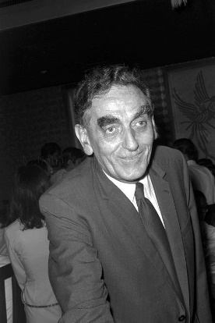 | - Official from the Colonial Government  - Public Relation officer of Singapore (1946-1954)  - He went on to be an academic who trained Singapore’s first diplomats  - http://www.nas.gov.sg/archivesonline/photographs/record-details/a27ac208-1162-11e3-83d5-0050568939ad
John Laycock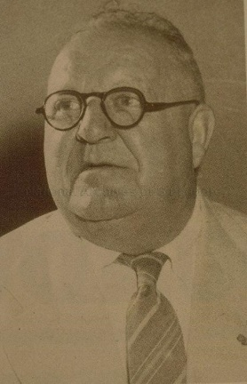 | - Member of Legislative Assembly for Katong  - Member of the Progressive Party  - Lawyer  - http://www.nas.gov.sg/archivesonline/photographs/record-details/a27ac208-1162-11e3-83d5-0050568939ad
C. R. Dasaratha Raj | - Member of Legislative Assembly for Rochore  - Member of the Labour Party
A. P. Rajah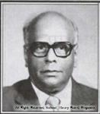 | - Member of the City Council  - He went on to become independent Singapore’s first Speaker of Parliament, Singapore’s first High Commissioner to Britain, and a member of the Supreme Court  - Lawyer  - http://eresources.nlb.gov.sg/printheritage/image.aspx?id=848f68f1-b8a2-45ac-8cbb-e5ebb6484337
S. Jaganathan | - Member of the City Council  - Member of the Labour Party  - General-Secretary of the Singapore Trades Union Congress and a founding member of the Labour Front.  - http://eresources.nlb.gov.sg/printheritage/image.aspx?id=848f68f1-b8a2-45ac-8cbb-e5ebb6484337
H. J. C. Kulasingha | - Member of the Rural Board  - Member of the Progressive Party  - Prominent member of the Singhalese community.

Figure 3 & 4: Major roads in Singapore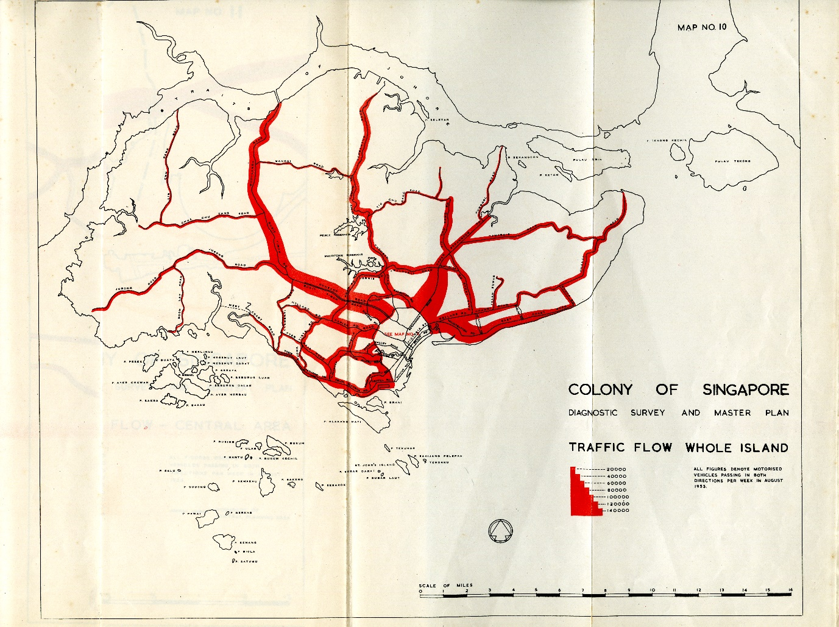
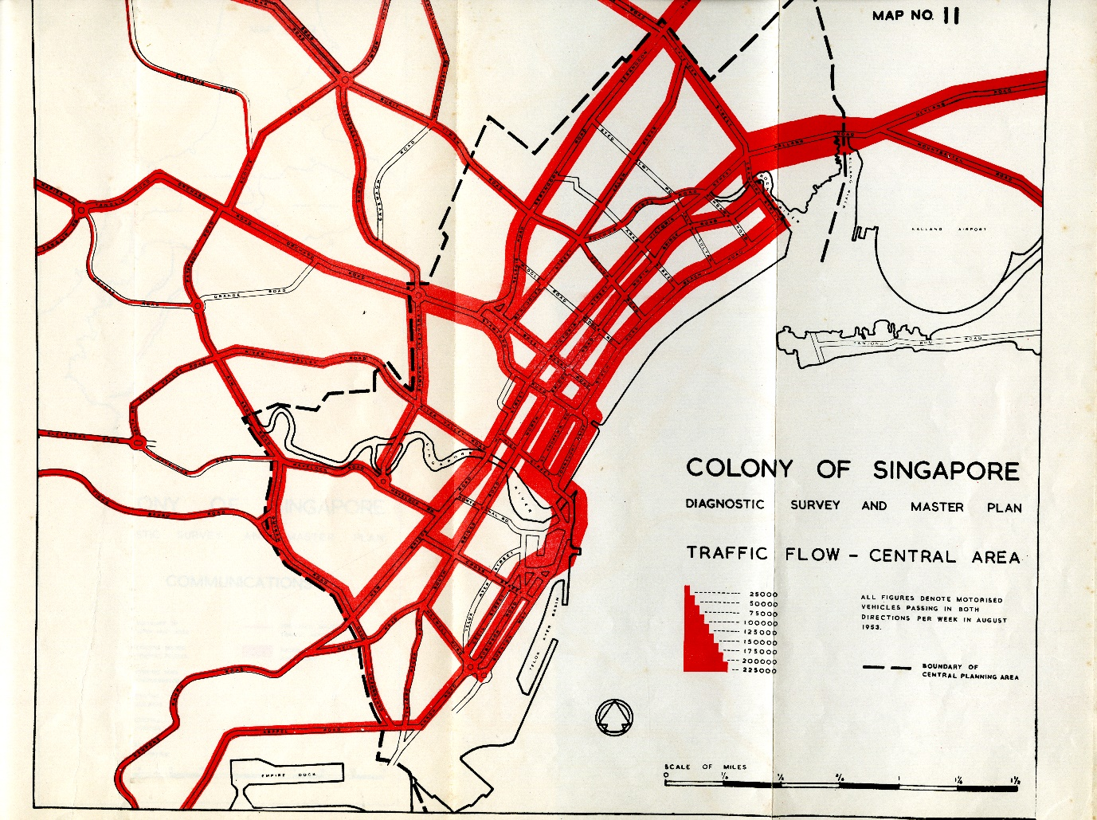

The Urban-Rural question
Now that the Boundaries Committee is drawn, they can finally start drawing maps. They worked off the recommendations of the Rendel Commission. Rendel’s overriding concern over districting was the balance of power between the fast-growing city and the rural kampungs.
Practically no one lives in Singapore’s Central Business District today, in 2019. But this is a recent development; in 1953, 340,900 people – one third of the population – crowded into a space smaller than almost all of Singapore’s modern New Town residential neighbourhoods. The central city – bounded by Kallang River in the East and Singapore General Hospital in the West had an average population density of 98,000 persons/km². In contrast, modern Tampines has a population density of 12,000 persons/ km². In the densest parts of the CBD, each person has less than 25 square feet of floor to themselves. That’s 2.3 square metres.
The Singapore Improvement Trust (SIT), the precusor to HDB, was founded primarily to build new housing estates to alleviate this housing shortage in the central city. By 1955, a number of new suburbs were built or in the process of being built – including Queenstown and Toa Payoh. Public works like Paya Lebar Airport were also in the midst of being built. There was genuine concern amongst planners and residents that the city and it’s increasing number of neighbourhoods are going to drown out the concerns and worries of rural kampung dwellers. Nevertheless, over 200,000 people lived in rural Singapore – 150,000 of whom lived in Attap houses. Due to Singapore’s post-war baby boom, Singapore’s rural population was actually increasing. Their stake in the new country needed to be protected.
A drastic attempt was made to protect the interests of Singapore’s kampung dwellers. The Rendel Report recommended that rural constituencies contain five times fewer people. This effectively would have meant that rural dwellers had five times the voting power when electing Members of the Legislative Assembly.
…The number of electors in a division would, however, vary from about 25,000 in densely populated areas to 5,000 in less populated areas.
We are anxious to ensure that the rural areas are fully and adequately represented in this new local authority (see paragraph 95 above), and all the more so because we have felt necessarily be resident in the division for which they stand. It is on this account that we envisage considerably smaller divisions in sparsely populated areas. We also recommend that as many divisions as possible should be “mixed”, i.e. partly urban and partly rural in character.
The Boundaries Committee agreed with Rendel that if Rural constituencies has as many people as urban constituencies, “the area would be so large that the feeling of community of interest would be dangerously diluted and even the most conscientious candidate would find it difficult to give the constituents the service they have a right to expect.
The Boundaries committee, however, argued that the difference in relative voting power between rural and urban residents should be minimise if possible to preserve equality and fairness. They ended up with:
- 8 Rural Constituencies, with an average population of 32,000.
- 5 “Mixed” Constituencies, with an average population of 37,000.
- 12 Urban Constituencies, with an average population of 55,000.

What Happened (to Singapore’s Rural countryside)?
All this precaution, however, proofed insufficient. The 1966 Land Acquisition Act allowed “for the acquisition of land for public and certain other specified purposes”. Kampung-dwellers were evicted and resettled in newly built HDB neighbourhoods. By 2010, 90% of Singapore’s land area has been nationalised and Singapore has been transformed into our modern city-state. Contiguity and Geographical Boundaries

Compactness and Communities of Interest
It made natural sense that people living in the same community share their representatives. Communities share political interests and are thus easier to represent. They share identities, friends, and family. But theories run into trouble the moment it is applied to the real world.
Due to sketchy record and census keeping in colonial Singapore and the limited electorate in, the Boundary Committee did not have a clear record of the geographical distribution of eligible votes.
There’s also the little problem of colonial Singapore barely had anything resembling civic or communal identity. There were, to be sure, communal identities – and various neighbourhoods and kampungs had distinct racial identities – but no one saw their neighbours as fellow members of a political community. This election was intended to build that sense of community and nationhood. One way this was to be done was by grouping people in constituencies with a common political stake.
Nevertheless, the Boundaries did the next thing –

K W Yeo, Political Development in Singapore, 1945-1955 (National University of Singapore (NUS) Press, 1973), p. 253.
Government of Singapore, Report of the Electoral Boundaries Delimitation Committee Singapore, 1954, p. 1.
C. J. Pattie D. J. Rossiter, Ronald John Johnston, The Boundary Commissions: Redrawing the UK’s Map of Parliamentary Constituencies (Manchester University Press, 1999).
C. J. Pattie and R. J. Johnston, ‘Local Battles in a National Landslide: Constituency Campaigning at the 2001 British General Election’, Political Geography, 22.4 (2003), 381–414 <https://doi.org/10.1016/S0962-6298(02)00097-5>.
George Rendel, Report of the Constitutional Commision of Singapore (Singapore, 1954), p. 27.
Government of Singapore, Report of the Electoral Boundaries Delimitation Committee Singapore, 1954, p. 4.
Practically no one lives in Singapore’s Central Business District today, in 2019. But this is a recent development; in 1953, 340,900 people – one third of the population – crowded into a space smaller than almost all of Singapore’s modern New Town residential neighbourhoods. The central city – bounded by Kallang River in the East and Singapore General Hospital in the West had an average population density of 98,000 persons/km2. In contrast, modern Tampines has a population density of 12,000 persons/ km2. In the densest parts of the CBD, each person has less than 25 square feet of floor to themselves. That’s 2.3 square metres.
Yeo, p. 255.
Yeo, p. 259.
Colony of Singapore, Master Plan Written Statement, 1955, p. 27.
George Rendel, Report of the Constitutional Commision of Singapore (Singapore, 1954), p. 27.
Government of Singapore, Report of the Electoral Boundaries Delimitation Committee Singapore, 1954, p. 4.
Land Acquisition Act (Singapore, 1966) <https://sso.agc.gov.sg/Act/LAA1966#pr6->.
Beng Huat Chua, ‘Disrupting Private Property Rights: National Public Housing Program’, in Liberalism Disavowed: Communitarianism and State Capitalism in Singapore (NUS Press, 2017), pp. 75–97.
Yeo, pp. 251–54.

